***Calligraphy***

*User Guide*

|  |  |  |
| --- | --- | --- |
| **Supervisor** | Sir Nirtan | |
| **Batch** | 2212d | |
| **Group** | CALLIGRAPHY  The art of beautiful writing | |
| **Serial No.** | **Enrollment Number** | **Student Name** |
| 1. | 1436406 | MARYAM |
| 2. | 1439929 | ZUBAIR |
| 3. | 1386749 | MOHSIN |
| 4. |  | MURTAZA |

***USER GUIDE***

**“**SCOOPES & SMILES” This Website is basically based on calligraphy and its different types . If you are passionate about calligraphy , so just this website is made for you.

**1. Top Layout**

This is the Top of the page.

* User can know about the website by clicking on About button
* Users can get touch to the admin by Registering their selves from home page.

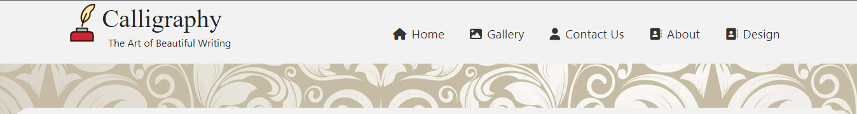

**2.** **Home Page**

* This page contain information about calligraphy and its different types & some fonts and writing with their details their details.

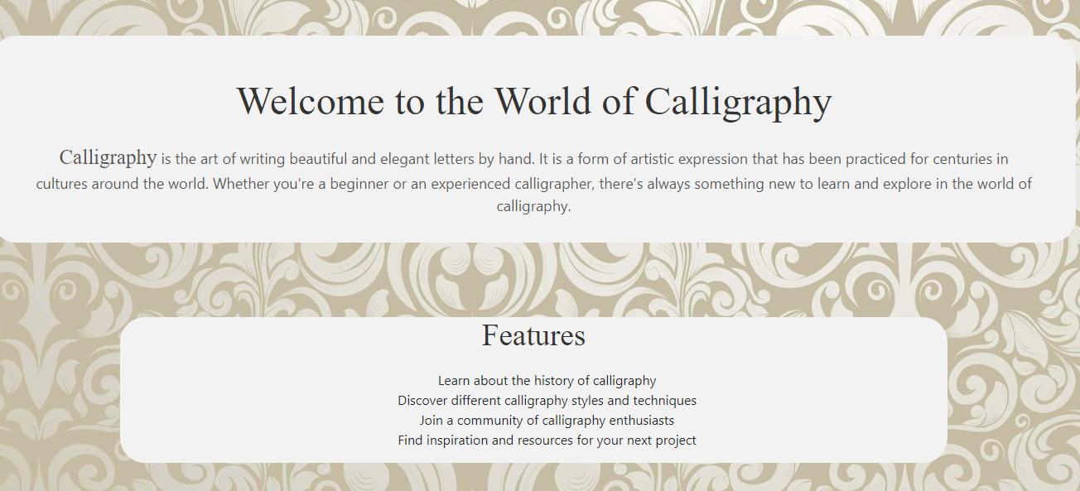

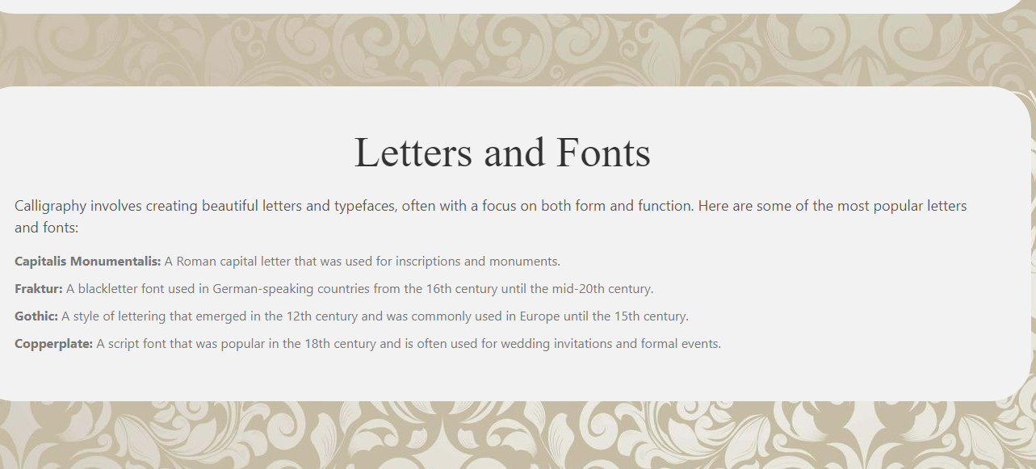

1. **Design Page**

This is the design Page.

* The user can use filter for getting info about any type they want

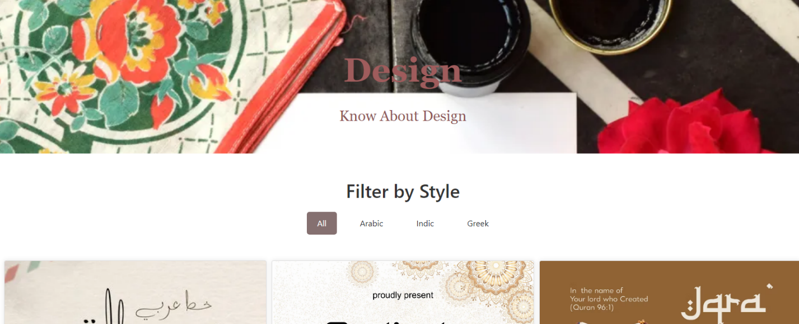

**4.** **Contact Page**

This is the Contact Page.

* In this page users can get in touch with us.
* They can leave their comment.

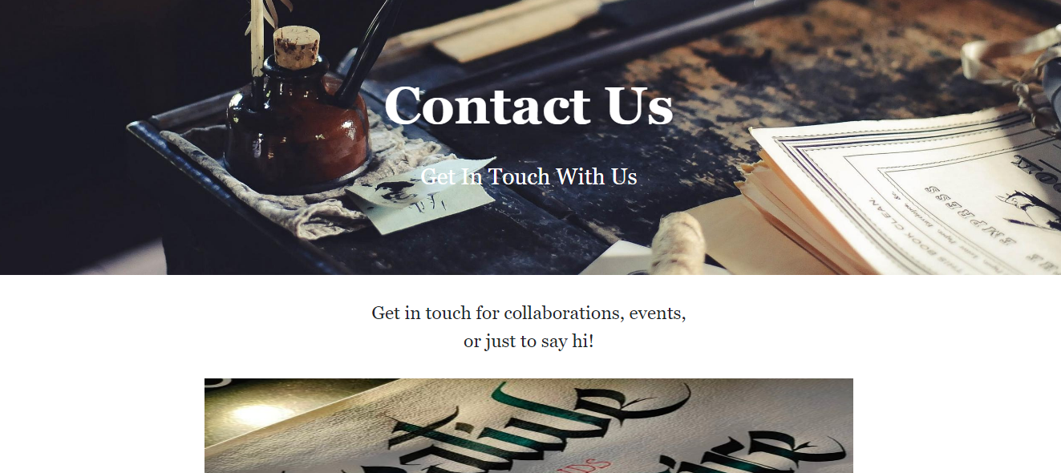

**5.** **About Page**

This is the About Us Page.

* This page has some Information about calligraphy

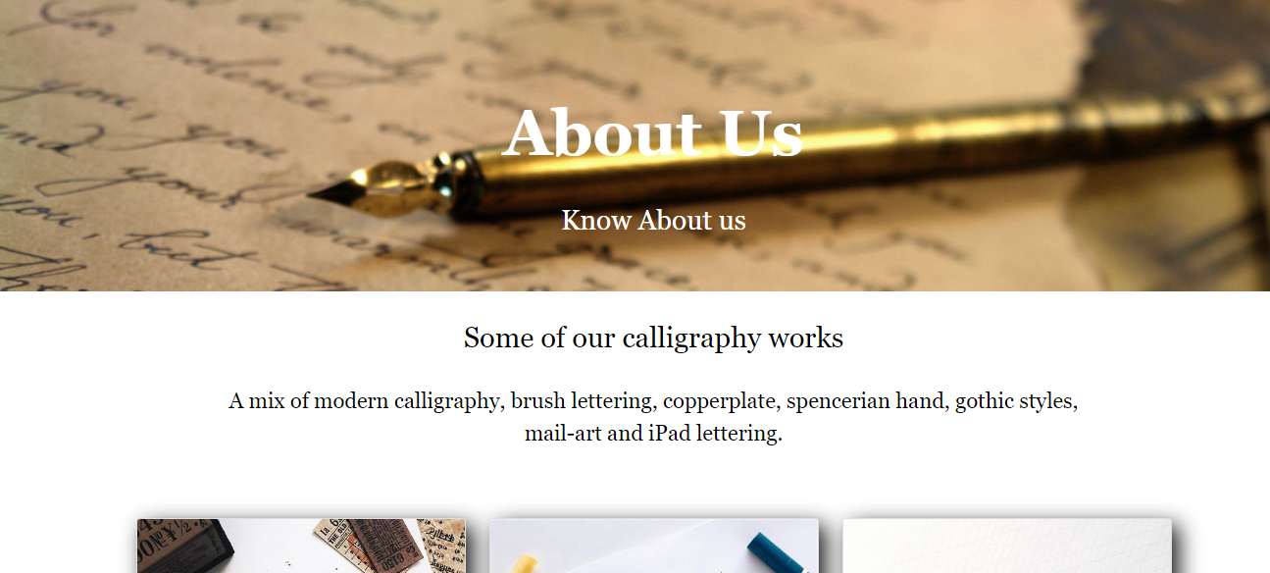

**6.** **Feed Back/Get Register**

* In this section user can leave their feedbacks.

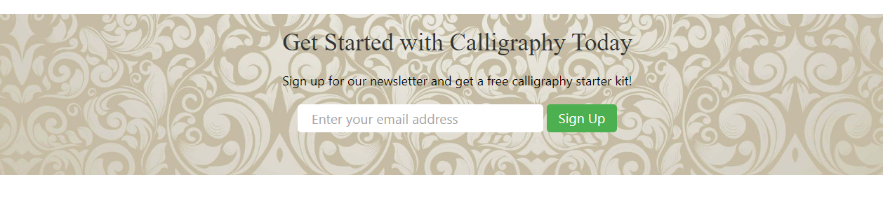

**7. Bottom Layout**

This is the Bottom of the page.

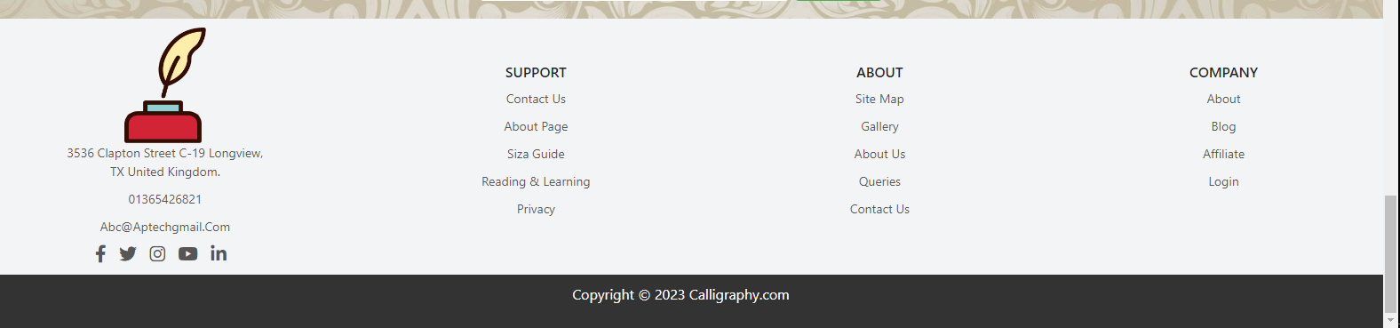

**We are really grateful to you for reading our documentation**